SOCIAL IDENTITY & PRIVILEGE ACTIVITY

Overview
The Social Identity Wheel worksheet is an activity that encourages students to identify and reflect on the various ways they identify socially, how those identities become visible or more keenly felt at different times, and how those identities impact the ways others perceive or treat them. The worksheet prompts students to fill in various social identities (such as race, gender, sex, ability disability, sexual orientation, etc.) and further categorize those identities based on which matter most in their self-perception and which matter most in others’ perception of them. The Social Identity Wheel can be used in conjunction with the Personal Identity Wheel to encourage students to reflect on the relationships and dissonances between their personal and social identities.

Goals
- To encourage students to consider their identities critically and how identities are more or less keenly felt in different social contexts. The classroom and the university can be highlighted as a context as a way to approach questions on barriers to inclusion.
- To illuminate how privilege operates to normalize some identities over others. For example, a student who speaks English as their first language can reflect on why they rarely need to think about their language as an aspect of their identity while some of their peers may identify language as the aspect of their identity they feel most keenly in the classroom.
- To sensitize students to their shared identities with their classmates as well as the diversity of identities in the classroom, building community and encouraging empathy.

Part 1. Spectrum Activity Questions
Consider your multiple identities. Fill out a social identity wheel to begin.

Social Identity Wheel (adapted from “Voices of Discovery”)
Image description: The chart below features a circle that is separated into 11 sections. Each section is labeled: (starting at the top and moving clockwise around the circle) ethnicity; socio-economic status; gender; sex; sexual orientation; national origin; first language; physical, emotional, developmental (dis)ability; age; religious or spiritual affiliation; race. In the center of the circle, there are five numbered prompts: (1) Identities you think about most often; (2) Identities you think about least often; (3) Your own identities you would like to know more about; (4) Identities that have the strongest effect on how you perceive yourself; (5) Identities that have the greatest effect on how others perceive you.

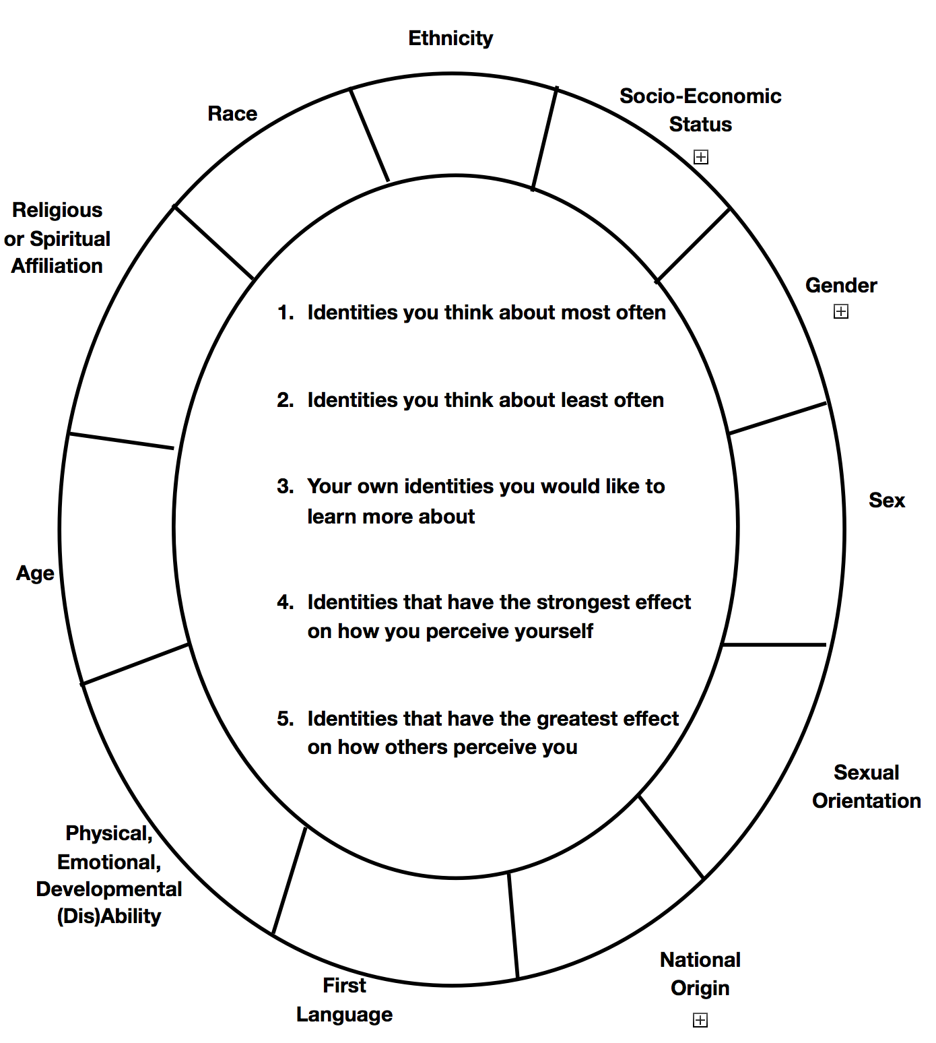
Part 2. Complete the following reflection questions.
- What part of your identity do you think people first notice about you?
- What part of your identity are you most comfortable sharing with other people?
- What part of your identity are you least comfortable sharing with other people?
- What part of your identity are you most proud of?
- What part of your identity did you struggle the most with growing up?
- What part of your identity is the most important to you?
- What part of your identity is least important to you?
- What part of other people’s identities do you notice first?
- For what part of your identity do you feel you face oppression for most often?
- For what part of your identity do you feel you receive privilege for most often?
- For what part of your identity do you feel least comfortable with at U of M?
- Your own identities you would like to learn more about.
- Identities that have the strongest effect on how you see yourself as a person.
- What part of your identity do you see having the most effect on your interactions with students?
- What part of students’ identities do you most often see effecting their interactions with you?
- What part of your identity do you see having the most effect on your interactions with co-workers/peers?

Citations: Adapted for use by the Spectrum Center and the Program on Intergroup Relations, University of Michigan.
Resource hosted by LSA Inclusive Teaching Initiative, University of Michigan (http://sites.lsa.umich.edu/inclusive-teaching/).

WHAT IS PRIVILEGE?
Reference: A resource from the National Association of School Psychologists
www.nasponline.org
Merriam-Webster’s Dictionary (2016) defines privilege as the following:
: a right or immunity granted as a peculiar benefit, advantage, or favor
: special enjoyment of a good or exemption from an evil or burden
: a special opportunity to do something that makes you proud
: the advantage that wealthy and powerful people have over other people in a society
NASP (2016) states that privilege is based on two concepts:
1. Privilege Includes Unearned Advantages That Are Highly Valued but Restricted to Certain Groups. Unearned advantages are those that someone receives by identifying or being born into a specific group. It is important to note that the groups who have received these advantages have not earned them due to their own hard work but rather their affiliation (e.g., being born into a wealthy family provides privileges that others do not have, such as accessing education as well as mental health and medical services; White Americans are more likely to walk into a mall without the suspicion of stealing). Equally important to note is the reality that while some benefit from unearned advantages, others are victims of unearned disadvantage. Unearned entitlements are things of value that all people should have; however, they are often restricted to certain groups because of the values of the majority culture that influence political and social decisions. The example below illustrates this concept.
Example: John (a boy) is perceived to understand science better than Jane (a girl). Although John and Jane are both in the same science class and have the same grades on their assignments and exams, because he’s a boy, John’s perceived superior understanding of science can become advantageous if he (rather than Jane) is encouraged to join science clubs. Over time, John’s participation in various science clubs may lead to receiving better grades in science and improve his chances of being accepted into more rigorous and competitive classes and programs in the future.
Privilege oppresses certain groups. As explained by Wildman and Davis (1995),
Members of the privileged group gain many benefits by their affiliation with the dominant side of the power system. Privileged advantage in societal relationships benefits the holder of privilege, who may receive deference, special knowledge, or a higher comfort level to guide societal interaction. Privilege is not visible to its holder; it is merely there, a part of the world, a way of life, simply the way things are. Others have a lack, an absence, a deficiency.
2. When Control or Power Has Been Given to One Group (Group A), This Group May Earn Privileges That Have Not Been Afforded to Other Groups (Group B and Group C). In other words, Group A can use their privileges to gain and exert even more power and influence over Groups B and C and thus enjoy privileges that are not accessible to others. The example below illustrates this concept:
A classroom teacher gives Group A the power to choose where they will sit during lunch. Due to the large number of students seated in the cafeteria during lunch, those who are seated closer to the exit doors are able to enjoy extra time at recess. Although Group A has not earned its right to sit near the exit doors (e.g., they did not complete a special task), because the teacher gave these students the power to choose their seats in the cafeteria, presumably because he/she liked them more than other students, Group A consequently controls the amount of time all students spend during recess.
Privilege exists when one group has something of value that is denied to others simply because of group membership and not based on what a person or group has done or failed to do (Johnson, 2006). For those who routinely benefit from privilege, the challenge is to not quickly deny its existence. It is important to recognize that privilege is a part of the reality that helps some while it impedes others’ experiences. For example, although being female or a person of color does not necessarily directly determine an outcome, these characteristics can easily and quickly make these individuals less likely to be hired, recognized, or rewarded in a variety of situations.
History of the Concept of Privilege
The concept of privilege can be seen in literature since W. E. B. Dubois wrote The Souls ofBlack Folk in 1903. In this book, he speaks of African Americans living in a world where they are not seen as just American, but as a “Negro” and an American. It further speaks to the concept that people of color are treated differently and that Caucasian Americans have an advantage over others due to the color of their skin. He wrote:
The Negro is a sort of seventh son, born with a veil, and gifted with second-sight in this American world—a world which yields him no true self-consciousness, but only lets him see himself through the revelation of the other world. It is a peculiar sensation, this double- consciousness, this sense of always looking at one’s self through the eyes of others, of measuring one’s soul by the tape of a world that looks on in amused contempt and pity. One ever feels his twoness—an American, a Negro; two souls, two thoughts, two reconciled strivings; two warring ideals in one dark body, whose dogged strength alone keeps it from being torn asunder.
In writing this paper I have also realized that white identity and status (as well as class identity and status) give me considerable power to choose whether to broach this subject and its trouble. I can pretty well decide whether to disappear and avoid and not listen and escape the dislike I may engender in other people through this essay, or interrupt, answer, interpret, preach, correct, criticize, and control to some extent what goes on in reaction to it.
Peggy McIntosh is an American professor who revitalized the concept of privilege in her 1988 essay “White privilege and male privilege: A personal account of coming to see correspondences through work in women’s studies.” As a White woman, she discusses the following:
Being white, I am given considerable power to escape many kinds of danger or penalty as well as to choose which risks I want to take.
Privilege Around Us
NASP (2016) illustrates that privilege is problematic (a) when it skews our personal interactions and judgments and (b) when it contributes to or blinds us to systemic barriers for those who do not possess a certain privilege, thereby creating or perpetuating inequity. In American culture, certain groups have the privilege of operating within settings—through no effort on their part—that are more conducive for their success, while others—through no fault of their own—find themselves in settings that make success more difficult (Miranda, Boland, & Hemmeler, 2009). Again, this concept refers to any advantage that is unearned, exclusive, and socially conferred. For example, with White privilege, White people are generally assumed to be law abiding until they show that they are not. On the other hand, people of color, in particular African Americans and Latinos, are routinely assumed to be criminals or potential criminals until they show that they are not (Johnson, 2006).
During this lesson, we will discuss the definitions that have already been provided. Throughout this
discussion, keep in mind that many types of privilege exist. In other words, people can be privileged
based on their racial/ethnic group membership, socioeconomic status, sexual orientation, gender
identity, or disability status. Because we cannot adequately address all types in this lesson, we will
focus on the concept of racial privilege. We also realize that this can be a difficult concept to
understand and the conversations that follow might be uncomfortable for you and/or your peers.
Note: Teachers may need to develop a safe place for students to feel comfortable with each other. Concerns of
confidentiality may need to be discussed (i.e., Vegas rules: what is discussed during this lesson/class should stay in the
classroom). If rapport has not already been established with their students, teachers may want to complete a trust
building activity before beginning the lesson. Throughout the lesson and activities, keep in mind that it is
possible for you to understand that different groups experience discrimination but not recognize the
manner in which you experience your own privilege. To truly understand how you encounter
privilege in your own life, it is necessary to take a close look at your personal experiences and
reactions to those of others.
We will begin by discussing the concept of racial privilege. Sue (2003) discusses the concept of White
privilege and defines it as follows:
The unearned advantages and benefits that accrue to White folks by virtue of a system normed on the experiences, values, and perceptions of their group. White privilege automatically confers dominance to one group, while subordinating groups of color in a descending relational hierarchy; it owes its existence to White supremacy; it is premised on the mistaken notion of individual meritocracy and deservedness (hard work, family values, and the like) rather than favoritism; it is deeply embedded in the structural, systematic, and cultural workings of U.S. society; and it operates within an invisible veil of unspoken and protected secrecy. (p. 137)
When thinking of the concept of White privilege, below are some advantages and disadvantages of being a recipient of White privilege.
Advantages
When you attend school, your race will be portrayed positively in the curriculum. Individuals who share your racial background will be presented as examples of those who have contributed to American history. For example, you and your friends will be taught about the United States’s presence in Europe during World War II to stop the Jewish Holocaust without a discussion of its Japanese internment camps. Another example might be the discussion of famous inventors in the United States, such as Thomas Edison and Henry Ford, who are predominantly White and male.
Disadvantages
The contributions of racial/ethnic minorities are limited, ignored, or portrayed negatively and/or in a stereotypic fashion. Examples include the portrayal of Native Americans as unsophisticated and in need of European (White) influence to better themselves; African American and Hispanic American history only being discussed during their designated months rather than throughout the year; Nat Turner’s slave “rebellion” (it’s presented as a rebellion to the slave owners instead of slaves fighting for their freedom); and viewing Dr. Martin Luther King Jr.’s “I Have A Dream” speech as his most significant contribution. (In fact, Dr. King spent a significant amount of time working to have the Voting Rights Act of 1965 passed by Congress as well as ending segregation and poverty.)
Understanding How Privilege Impacts Opportunities to Learn
There are many other types of privilege that exist in our society. Another example of privilege
involves having an “understanding of the Haves and Have-Nots” (Miranda, Boland, Hemmeler,
2009). For example, Student A comes from a family in which the parent/guardian works from 8:00
a.m. until 4:30 p.m. and makes a large enough income so that the student can attend a private
preschool. The family’s income also allows the student to travel in a car to museums or other
academically rich activities over the weekend. The parent is home at night and can review homework
and read to the child before bed. On the other hand, Student B comes from a family in which the
parent/guardian works two jobs from 1:00 p.m. until 1:00 a.m. A grandparent stays at the home to
assist with child care because the parent cannot afford preschool and could not get onto the waiting
list for Head Start. Although the grandparent makes sure that all of the student’s basic needs are
met, the family cannot afford books to read at home and does not have a car to go to the public
library. The family relies on public transportation, and the bus runs on a limited schedule during
weekends. Both students enter kindergarten. Student A easily learned the topics that are being taught
(i.e., letters, numbers, basic letter sounds) because they were already exposed to these concepts in
preschool. Student B, however, struggles because this is the first time the student has been exposed
to these concepts. The teacher assumes that Student A is highly intelligent because the student
understands many of the topics that are taught in class. The teacher assumes that Student B will
continue to struggle in school because the student is not learning at the same pace as the other
students in the classroom. From this illustration, socioeconomic status (SES) is another example of
how privilege affects the opportunities people have in our society.

PRIVILEGE APTITUDE TEST
Adapted From the National Civil Rights Museum at the Lorraine Motel https://civilrightsmuseum.org/wp-content/uploads/2014/03 /YouthPrivilegeAptitudeTest.pdf
Directions: Answer each of the following questions with YES or NO. If your answer is YES, give yourself 1 point. If your answer is NO, give yourself 0 points. After you have answered each of the questions, add up all of your points. Please complete this activity without any assistance from your teacher or friends. Also, because everyone is different, your friends will likely have different answers that don’t apply to you. Very importantly, there are no right or wrong answers.

Item Number | Item | Yes | No | Points (0 or 1)
1 | When I go to the store, people believe that I am trustworthy and I will not steal something. People in the store do not follow me around.
2 | As a boy I can play with dolls or as a girl I can play with trucks without anyone questioning my choice.
3 | I can walk after dark in public places without fear. I am not taught to fear walking alone after dark in most public spaces.
4 | When I am taught about American history or about contributions made, I am sure that I will see and hear stories about people who look like me.
5 | The majority of the staff at my school look like me.
6 | My school has plenty of books in the library, computers for students, and additional resources for students and teachers.
7 | I will not be teased because of my last name.
8 | I am encouraged to excel in every subject in school.
9 | When a question about my race is asked, I am not the only one singled out to answer or speak my opinion.
10 | When I watch television, there are a lot of people in positive roles that look like me.
11 | My intelligence is not questioned because of the way I speak.
12 | Using public bathrooms and going up and down the stairs in public spaces are easy for me.
Total Points

REFLECTION QUESTIONS
- How did you feel about this activity?
- As you were reading and answering the questions, how did you feel?
- Please describe your feelings to the others in your group.
- As you were reading the questions, can you think of other questions that should have been
asked?
- If you were creating your own privilege survey, what additional questions would you include on the survey? What are your reasons for including these questions?
- Would you remove or rephrase any of the questions above? If so, why?
- How does your TOTAL SCORE compare to other students in your group?
- Why do you think that the scores are different for people in your group?
- As a group, choose to discuss specific questions from the survey.
- Why did you choose to discuss these questions?

Exit Card
- List one thing that you learned about privilege.
- What are two things that you found out makes you privileged?
- Starting today, how can you raise awareness about privilege with your friends and/or family?
- How did the lesson impact you? What emotions did you experience/feel?
Reference: Social Justice A resource from the National Association of School Psychologists │ www.nasponline.org │ 301-657-0270

